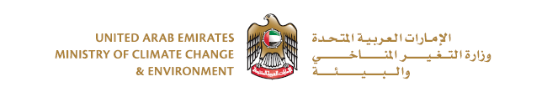

**Issuance Import permit for Semen or Embryos**

|  |  |  |  |
| --- | --- | --- | --- |
| **NAME OF IMPORTER** |  | | |
| **TELEPHONE NUMBER** |  | **FAX NO** |  |
| **POSTAL ADDRESS** |  | | |

|  |  |
| --- | --- |
| **COUNTRY OF DISPATCH** |  |
| **APPROVED COLLECTION SITE: (Name & No.)** |  |
|  |
|  |
| **AIRPORT OF ARRIVAL** |  |

|  |  |
| --- | --- |
| **DETAILS OF CONSIGNEMENT** | |
| **NAME OF STALLION** | **VOLUME/NUMBERS OF STRAWS** |
|  |  |
|  |  |
|  |  |

Name of Applicant:____________________________

Signature: __________________________________